Clause as Subject

✅ What is Clause as Subject
# Source: AI Source: Provided by: [Data Path: Persons Table -> ID Column: 1, Name_En Column: Motasem Essam] -> From: [Chatgpt (GPT-4-turbo)] on [8/4/2025]
A clause as subject refers broadly to any clause—nominal (noun) clause, infinitive clause, or gerund clause—that functions as the subject of a sentence.
It acts like a noun and performs the role of the doer or topic in the sentence.

🔹 Types of Clauses That Can Function as Subjects:
# Source: AI Source: Provided by: [Data Path: Persons Table -> ID Column: 1, Name_En Column: Motasem Essam] -> From: [Chatgpt (GPT-4-turbo)] on [8/4/2025]
- Noun (Nominal) Clause – e.g., What you said was true.
- Infinitive Clause – e.g., To finish early is important.
- Gerund Clause – e.g., Running in the morning helps me focus.
All these are considered clauses as subjects because they contain a verb and function grammatically as subjects.

🔹 Key Features:
# Source: AI Source: Provided by: [Data Path: Persons Table -> ID Column: 1, Name_En Column: Motasem Essam] -> From: [Chatgpt (GPT-4-turbo)] on [8/4/2025]
- Functions as a single grammatical subject.
- Usually appears at the beginning of a sentence.
- May be long and complex.
- Verb agreement depends on the whole clause, not just part of it.

🔹 Examples:
# Source: AI Source: Provided by: [Data Path: Persons Table -> ID Column: 1, Name_En Column: Motasem Essam] -> From: [Chatgpt (GPT-4-turbo)] on [8/4/2025]
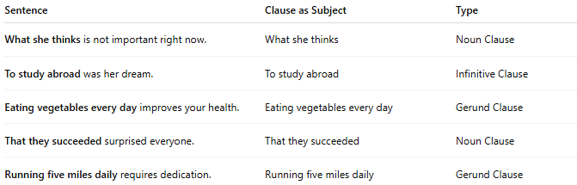
Sentence | Clause as Subject | Type
What she thinks is not important right now. | What she thinks | Noun Clause
To study abroad was her dream. | To study abroad | Infinitive Clause
Eating vegetables every day improves your health. | Eating vegetables every day | Gerund Clause
That they succeeded surprised everyone. | That they succeeded | Noun Clause
Running five miles daily requires dedication. | Running five miles daily | Gerund Clause

🔍 Quick Test:
# Source: AI Source: Provided by: [Data Path: Persons Table -> ID Column: 1, Name_En Column: Motasem Essam] -> From: [Chatgpt (GPT-4-turbo)] on [8/4/2025]
If the subject is not a single noun or noun phrase, but a group of words with a verb, it is likely a clause as subject.

